DESIGN AND IMPLEMENTATION OF AN INVENTORY MANAGEMENT SYSTEM FOR TEXTILE RETAIL STORES: A CASE STUDY OF GALADAWA TEXTILE SHOP

BY
AHMAD SHUAIBU
(CST/22/IFT/00847)
BEING A PROJECT SUBMITTED TO THE DEPARTMENT OF INFORMATION TECHNOLOGY, FACULTY OF COMPUTING, BAYERO UNIVERSITY KANO IN PARTIAL FULFILMENT OF THE REQUIREMENT FOR THE AWARD OF DEGREE IN INFORMATION TECHNOLOGY.

SUPERVISED BY: PROF. IBRAHIM ALHAJI LAWAL

MARCH 2026

DECLARATION
I, AHMAD SHUAIBU declare that this project work is the product of my own endeavor and that all sources have been adequately and duly acknowledged and that all the inadequacies in this project work are the product of my own shortcomings. And that this project paper has not been submitted in this faculty or elsewhere.

DEDICATION
This project is dedicated to Almighty Allah, whose guidance, mercy, and strength made the successful completion of this work possible.
It is also dedicated to my parents, whose sacrifices, prayers, discipline, and unwavering support laid the foundation for my academic journey. Their commitment and belief in my potential remain my greatest source of motivation.
I further dedicate this work to my family members and relatives for their constant encouragement, understanding, and support throughout my studies.
Finally, this project is dedicated to my friends and course mates in the Department of Information Technology, Faculty of Computing, Bayero University Kano, whose cooperation, shared experiences, and collective effort contributed significantly to this achievement.
This work stands as a reflection of the collective support and influence of all those who played a role, directly or indirectly, in my academic success.

APPROVAL PAGE
This project has been read and approved as meeting the requirements for the Bachelor of Science project in the Department of Information Technology, Faculty of Computing, Bayero University Kano.

................................... .................................
Prof. Ibrahim A Lawal DATE
Supervisor

..................................... ....................................
Ass. Prof. Faruk Umar Ambursa DATE
Head of Department

.................................... ....................................
External Examiner DATE

ACKNOWLEDGEMENT
I express my profound gratitude to Almighty Allah for His guidance, protection, and strength throughout the course of this research and my entire academic journey.
I sincerely appreciate my project supervisor for the invaluable guidance, constructive criticism, and professional support that shaped this work and ensured it met academic standards. I also acknowledge the efforts of the lecturers and staff of the Department of Information Technology, Faculty of Computing, Bayero University Kano, whose knowledge, discipline, and mentorship contributed significantly to my academic development.
My appreciation extends to the management and staff of Galadawa Textile Shop for their cooperation, access to relevant information, and willingness to support this study. Their practical insights were instrumental to the success of this project.
I am deeply grateful to my parents, family members, and relatives for their unwavering support, prayers, and sacrifices throughout my education. Their encouragement provided the stability and motivation required to complete this work.
Finally, I acknowledge my friends and course mates for their cooperation, intellectual exchange, and moral support during the course of this project. Each contribution, whether direct or indirect, played a meaningful role in the successful completion of this research.

ABSTRACT
The traditional reliance on manual bookkeeping in textile retail stores often results in highly inaccurate stock tracking, pervasive human errors during daily sales processing, and frequent disputes regarding staff commission calculations. To resolve these core operational inefficiencies, the main objective of this study was to design and implement a robust, web-based inventory management system specifically tailored for Galadawa Textiles. The project strictly adopted the Waterfall software development methodology, ensuring a systematic and sequential progression through requirement analysis, system design, implementation, and testing phases, utilizing standard web technologies including PHP for the dynamic backend logic and MySQL for secure, relational database management. The developed system boasts several key features, including a centralized administrative dashboard for real-time global inventory control and user management, alongside an intuitive Point of Sale (POS) interface that enables sales attendants to efficiently process customer transactions and instantly generate digital receipts. Furthermore, the application integrates an automated commission engine that accurately computes staff earnings per individual sale and seamlessly facilitates a transparent payout request workflow. The findings from this research project firmly conclude that transitioning from physical ledgers to a centralized digital platform significantly eliminates data inconsistencies, substantially mitigates the risk of record loss, and fosters a much higher level of financial accountability and trust between management and the sales staff. To maximize the system's overall effectiveness and ensure long-term operational success, it is highly recommended that the store management conducts comprehensive, hands-on training for all users to familiarize them with the digital POS operations, and strategically invests in Uninterruptible Power Supply (UPS) systems and reliable internet infrastructure to prevent any transaction disruptions during unexpected power outages.

Table of Contents
DECLARATION I
DEDICATION II
APPROVAL PAGE III
ACKNOWLEDGEMENT IV
ABSTRACT V
LIST OF TABLES IX
LIST OF FIGURES X
CHAPTER ONE 1
INTRODUCTION 1
1.1 Background of the Study 1
1.2 Statement of the Problem 3
1.3 Research Questions 4
1.4 Aim and Objectives 4
1.5 Scope and Limitations 5
1.6 Significance of the Project 5
1.7 Project Document Organization 6
CHAPTER TWO 7
LITERATURE REVIEW 7
2.1 Introduction 7
2.2 Concept of Inventory 7
2.2.1 Inventory Management 8
2.2.2 Types of Inventories 8
2.2.3 Inventory Management Systems 10
2.2.4 Manual Inventory Management System 11
2.2.5 Computerized Inventory Management System 11
2.3 Review of Related Works 12
2.4 Summary 17
CHAPTER THREE 18
SYSTEM ANALYSIS AND DESIGN 18
3.1 Introduction 18
3.2 System Analysis 18
3.2.1 Method of System Analysis 18
3.2.2 Investigation and Analysis of the existing System 18
3.2.3 Problems with the existing system 19
3.2.4 Requirements Definition 19
i. The system shall enforce two distinct user roles with specific permissions 19
3.2.5. Requirement Analysis 20
3.3 System Design 28
3.3.1 Description of the Proposed System 29
3.3.2 System Development Model 32
3.3.3 Architecture Design 33
3.3.4 Database Design 34
3.3.5 Choice of Programming Language 34
3.4 Summary 35
CHAPTER FOUR 36
SYSTEM IMPLEMENTATION AND TESTING 36
4.1 Introduction 36
4.2 System Implementation 36
4.2.1 Implementation Tools 36
4.2.2 Algorithms of Major Functionality 37
4.2.3 Description of the developed System 40
4.3 System Testing 44
4.3.1 Testing Tools 44
4.3.2 Unit Testing 44
4.3.3 IntegrationTesting 46
4.3.4 System Testing 48
4.3.5 Usability Testing 49
4.4 Summary 49
CHAPTER FIVE 50
SUMMARY, CONCLUSION AND RECOMMENDATIONS 50
5.1 Summary 50
5.2 Conclusion 51
5.3 Recommendations 51
5.3.1 Operational Recommendations for the Store 51
5.3.2 Recommendations for Future Enhancement 51
REFERENCES 53
APPENDIX 55

LIST OF TABLES
Table 1 Process Sale Use Case Description 25
Table 2 Add New Product Use Case Description 26
Table 3 Request Commission Payout Use Case Description 27
Table 4 Testing Tools 44
Table 5 Test Case 1: User Aut hentication (Login) 45
Table 6 Test Case 2: New Product Registration 45
Table 7 Test Case 3: POS Stock Validation 46
Table 8 Test Case 1: POS and Inventory Module Integration 46
Table 9 Test Case 2: POS and User Commission Integration 47
Table 10 Test Case 3: Payout Request and Admin Approval Integration 47

LIST OF FIGURES
Figure 1 Use Case Diagram of the Galadawa Inventory Management System 22
Figure 2 Sale Attendant Use Case Diagram 23
Figure 3 Admin Use Case Diagram 24
Figure 4 Activity Diagram of the Proposed System 29
Figure 5 Sequence Diagram of the Proposed System 31
Figure 6 waterfall model 32
Figure 7 Architecture Design of the Proposed System 33
Figure 8 Entity Relationship Diagram of the Proposed System 34
Figure 9 User authentication Module. 41
Figure 10 Administrator Dashboard Module. 41
Figure 11 Add Product Page Module. 42
Figure 12 Point of Sale (POS) and Cart Interface Module. 43
Figure 13 Commission and Payout Request Module. 43

CHAPTER ONE

INTRODUCTION

1.1 Background of the Study
Inventory management is an essential function in the management of business operations, especially in retail businesses where the availability of products is an important determinant of sales performance. In essence, inventory forms part of the business assets, and its management ensures the availability of products while at the same time reducing the cost of overstocking, spoilage, and losses. As the business grows, the complexity of managing the inventory increases, making efficient inventory control systems essential in the management of business operations (Fahmi et al., 2025).
For instance, small and medium-scale retail enterprises have often employed traditional manual inventory control techniques, including written records of goods, sales receipts, and memory-based inventory tracking systems. However, as the scale of transactions increases, these traditional techniques may prove to be inefficient for inventory control purposes. Generally, manual inventory control techniques are often associated with problems such as inaccuracy, delay in updating records, difficulty in tracking inventory, and generating reports for decision-making purposes, which may adversely affect efficiency(Fahmi et al., 2025).
Inventory management is a strategic link between what customers want and what's available in retail business. When inventory management goes awry, shortages start to appear, which may result in loss of sales and dissatisfied customers. Conversely, overstocking may lead to an increase in holding costs. Research indicates that effective inventory management can help in improving productivity, reducing operational costs, and improving customer service(Fahmi et al., 2025).
The use of information technology in running businesses, particularly in the management of inventories, has been revolutionary. Through the use of digital systems in managing inventories, businesses are able to track their inventories in an automatic manner, keep track of the quantities in real time, and generate precise reports concerning the same.As(Dwiwijaya, 2024) puts it, computerized information systems make the data precise, efficient, and strategic in the modern business world.
The retail industry is built on effective inventory management, considering that inventory on hand is a direct source of meeting customer demand. Inventory management, therefore, is not just about maintaining inventory on the retail floor, but also about tracking all movements of inventory, beginning from when the inventory is purchased to when it is sold to a customer. This is a strategy for responding to market dynamics, reducing costs, and improving business success (Gomes et al., 2023).
Textile retail shops have unique challenges in managing their inventory compared to other retail shops. Textiles vary in terms of lengths, patterns, colors, and fabric composition. Textiles are also available in yardage or roll quantities. This makes managing inventory more challenging for these shops, especially if they are manually managing their inventory system. There are high chances of errors in measurement, recording, and pricing of the products (Ahmad et al., 2020).
In many developing countries, including Nigeria, small and medium-sized textile retailers use manual methods to manage their inventories. They use a pen and paper to keep records of their stocks, which may seem cost-effective at the beginning but can cause more harm as one may not know the exact position of the stock(Gaborno et al., n.d.)
With the advent of the digital transformation of the retail industry, the limitations of manual inventory management have been highlighted. Automated inventory management systems provide solutions that increase the precision, speed, and security of inventory management. Digital inventory management allows retailers to monitor inventory, generate sales reports, inventory reports, and make smart management decisions that can be easily backed up. Research shows that the adoption of computerized inventory management systems significantly improves inventory management in the retail industry (Siregar & Sudarmanto, 2023).
The retail industry of textiles in Nigeria is an integral part of the local economy, providing employment and facilitating the distribution of fabric to consumers for clothing, cultural attire, and home decor. However, despite its significance to the local economy, the retail industry of textiles operates with low-tech inventory management systems. This has led to challenges that have undermined the viability of these retail businesses (Muhammad, 2018).
A shop like Galadawa Textile Shop in Gusau, Zamfara State, seems to fit right into this picture. Like many small to mid-sized textile businesses, it uses mostly old-fashioned ways to keep track of inventory. Its inventory is recorded in a ledger, and changes to that inventory after each sale are done manually. With sales measured by yard and by units for caps, it’s easy to see how quickly things could get complicated, especially when dealing with a high volume of customers.
As affordable computing technology becomes more accessible to small retailers, there is a genuine opportunity for them to improve efficiency through increased automation. A well-designed computerized system for managing inventory can help minimize the problems associated with a manual system. It can automate processes for tracking inventories, monitor sales in real-time, keep track of exact amounts of items on hand, and generate accurate reports for management (Shazna, 2021).
This project explores the development and implementation of a computerized system for managing inventories for textile retail shops. It uses the case study of Galadawa Textile Shop. Its main objectives include improving control over inventories, increasing efficiency in daily operations, reducing human error, and supporting more informed decision-making. This project contributes to the implementation of modern information systems in small to medium-sized retail enterprises that require specialized solutions for textile retail operations.

1.2 Statement of the Problem
Effective management of inventory is vital for the successful management of retail businesses, especially in textile shops where products vary depending on type, color, design, and unit of measurement. However, despite its significance, many small and medium-sized retail businesses in the textile industry still rely on traditional methods of managing inventory that are no longer effective in today’s business world (Shazna, 2021).
At Galadawa Textile Shop, the method of tracking their stock is not automated. They use stock books where all their stock is recorded. Every time they make a sale, they manually subtract the stock sold from their stock. The problem with this method is that it greatly relies on memory and accurate counting. However, this can prove to be difficult, especially when there are many customers. The result is that there are many errors in stock counting.
The problem with this method is that there is no real-time information. As a result, there are cases where there is a shortage or excess stock. Both cases are detrimental to sales as well as how efficiently the capital is being utilized. The process of generating sales reports is slow and not very accurate. As a result, it is difficult to make informed decisions as a management (Swastyastu et al., 2024).
Physical inventory data may also be lost, destroyed, or fall into unauthorized hands. The business may also face significant operational risks when data security is weak and data backup is poor. This negatively impacts efficiency, costs, and growth (Swastyastu et al., 2024).
The existing method adopted by Galadawa Textile Shop for managing its inventory is not adequate for the task. It is not adequate for effective control and decision-making. There is therefore a clear need for a computerized method for managing the inventory to automate the processes involved, enhance accuracy, provide real-time stock information, and ease the management of a textile retail business.

1.3 Research Questions
- What are the practices currently being used by Galadawa Textile Shop in its inventory management system?
- What are the challenges in the current manual method of inventory management being practiced by Galadawa Textile Shop?
- How can a computerized inventory management system enhance stock tracking accuracy, operational efficiency, and inventory control in Galadawa textiles?

1.4 Aim and Objectives
This study will concentrate on developing and implementing an inventory control system that will specifically apply to textile retail shops, with a specific case study at the Galadawa Textile Shop. This will improve the way inventory control is handled, enhance efficiency, and assist in making exact decisions. The objectives are:
- To identify the existing inventory management practices at Galadawa Textile Shop.
- To design and implement a user-friendly web-based inventory management system tailored to the operational needs of Galadawa Textiles Shop.
- To evaluate the effectiveness of the developed system in reducing data redundancy, ensuring data consistency, and improving the accuracy of inventory records at Galadawa Textile Shop.

1.5 Scope and Limitations
This study aims to examine how to build and put into use an inventory management system particularly for textile retail, using Galadawa Textile Shop as a case study. The goal is to manage textile products sold by piece and by yards, record all sales, keep track of stock levels automatically, and generate easy-to-understand inventory and sales reports. The study is focused on the daily activities in a textile store, particularly for one textile store.
The project will be developed as a web-based application using the latest technologies. It will also be tested in a real-world environment at Galadawa Textile Shop. The study will cover all phases from system analysis to implementation and testing, particularly in boosting how to better manage the store’s inventory and how to run its daily activities more efficiently.
The developed system is particularly designed for textile retail and can’t be applied to other types of retail shops without certain modifications. The study is limited to a single case, which can’t be applied to other textile shops.
However, there are other constraints that can affect the performance of the system. These include basic computing facilities and users who are familiar with computer-based systems. There are also other constraints outside the system’s control, including power stability, internet stability, and users’ willingness to use technology. These constraints are taken into consideration in building the system.

1.6 Significance of the Project
This study is significant because it provides a solution to the problems often encountered by textile retailers regarding their inventory systems. This study provides a solution to this problem by implementing a computerized inventory system for Galadawa Textile Shop.
For retailers, this system provides live monitoring, cutting losses due to stockout and overstock situations. It speeds up restocking decisions and minimizes human errors resulting from manual record-keeping. It provides sharper financial oversight through accurate sales and inventory reporting.
For employees, this system provides easier inventory handling, a lighter workload, and a more convenient work process. Customers also benefit indirectly by having more convenient services.
For its academic significance, this study contributes to the pool of knowledge regarding inventory management systems and provides a reference for students and scholars in the field of Information Technology and its related fields. This study also provides a platform for demonstrating the practical application of software development principles for small and medium-sized enterprises.

1.7 Project Document Organization
It is a five chapter project that is structured to promote clear thinking, logical thinking, and adherence to guidelines set by the Faculty of Computing.
Chapter One: Introduction,This chapter includes a background of the study, a problem to be addressed, objectives, importance of the study, scope, and limitation of the study, as well as a summary of what this chapter entails.
Chapter Two: Literature Review, In this chapter, we'll discuss the literature on inventory management systems, how textile retailers operate their businesses, and what already exists in terms of computerized inventory management systems.
Chapter Three: System Analysis and Design, This chapter focuses on the analysis and design of the proposed inventory management system. It discusses what the system needs (requirements), how the processes are performed (process modeling), how the data is organized (database design), the structure of the entire system (system architecture), and the details of the design required for the implementation of the entire system.
Chapter Four: System Implementation and Testing, In this chapter, we'll present how the proposed inventory management system is implemented. It discusses the tools and technologies used in the development of the proposed inventory management system.
Chapter Five: Summary, Conclusion, and Recommendations, The final chapter is a summary of the entire study. It also presents the conclusions drawn from the research findings and the recommendations for future enhancements and further research.
The layout of the chapters makes it possible for the study to be presented in a clear, orderly, and acadically sound way.

CHAPTER TWO

LITERATURE REVIEW

2.1 Introduction
This chapter is a survey of the existing literature on inventory management systems, specifically focusing on retail and textile industry operations. It is meant to be an in-depth look at the concepts, techniques, and systems that exist in the area of inventory management, including what works well and what does not, and what needs to be further explored in the literature. It begins with the basics of what inventory is and how inventory management works, and then goes into computerized inventory management and the literature on that topic. This chapter lays the groundwork theoretically and explains why the need exists for a new inventory management system at the Galadawa Textile Shop.

2.2 Concept of Inventory
Inventory is the goods that an enterprise has stored for the purpose of resale, manufacturing, or for the smooth operation of the enterprise. For the retail sector, it is the products that the enterprise has purchased for the purpose of holding them in reserve for resale. The importance of good inventory management is that it has a significant impact on the working capital of the enterprise, as inventory is the biggest working capital component, and it has an impact on the profitability as well as the quality of service provided by the enterprise (Obadire et al., 2022).
In textile stores, the inventory mostly consists of fabrics, which come in rolls or yards. Textile inventory is quite different from the normal inventory in that it requires attention to the quantity and length of the goods in the store. Lack of proper handling may result in stock deficiencies, excess or insufficient stock, and incorrect pricing, leading to revenue loss.
Many researchers have pointed out that inventory is the bridge between the suppliers and customers, and inventory helps maintain the stability of the business operations. It is always beneficial to maintain the inventory at the right levels to meet the demands while reducing the costs, waste, and losses incurred due to the inventory (Heizer et al., 2017).
In the retail world of today, inventory is not just the items on the shelves, but also the exact data regarding the quantity of items available, the items that are selling, and when more stock is needed. This progression towards an information-based approach demonstrates the importance of good records being kept. With the expansion and sophistication of stores, good records cannot be maintained manually, thus the need for computerized systems for inventory management (Pooja A R et al., 2024).

2.2.1 Inventory Management
Inventory management is the systematic process of planning, arranging, supervising, and controlling inventory with the objective of having sufficient quantities of goods available when they are required at the least possible cost. It entails decisions regarding purchasing, storage locations, tracking, and moving of goods with the objective of meeting customer demand while avoiding excess inventory and stockouts (A, n.d.).
In retail businesses, efficient management of inventory is vital to success and profitability because it reduces storage expenses and prevents losses resulting from theft or obsolescence of goods. It also allows a business to meet customer needs without exceeding the financial constraint of inventory (Pooja A R et al., 2024).
Textile retailers have their own set of problems when it comes to managing their inventory levels. Textiles come in all shapes and sizes, and it is difficult to maintain accurate figures in this case. If inventory levels are not managed properly in textile retailers, you may end up with incorrect information regarding the stock levels (Pooja A R et al., 2024).
For small and medium-scale textile businesses, many use a pen-and-paper approach to manage their inventory. Though this may work for a very small scale, as order volumes increase, this method becomes inefficient, prone to errors, and time-wasting. Research suggests that this method often results in data inconsistencies, thereby delaying decision-making (Shazna, 2021).
The development of computerized inventory management systems has changed the way retailers manage their inventory. By increasing the accuracy and efficiency of item recording, tracking, and reporting, computerized systems have been very helpful in making informed decisions regarding inventory and sales, as they offer real-time data on inventory (Shazna, 2021).
In this study, inventory management refers to an essential activity that can be enhanced through a tailored computerized system that suits the requirements of textile retailers' operations, such as Galadawa Textile Shop.

2.2.2 Types of Inventories
Inventory may be categorized based on the objective or the stage of the business workflow. Understanding the different types of inventory is critical for effective management, as different types require different methods of management.
- The raw materials are the items which have not yet been transformed into finished products. This type of stock is common in manufacturing industries, although it is not so common in textile retail stores, which normally purchase already finished products.
- The work-in-progress inventory comprises those goods that are still in the process stage before they are converted into the finished goods. Textile retail shops rarely maintain this type of inventory since the goods sold are fabric materials that rarely undergo any process before sale.
- Finished goods inventory refers to the goods that are ready to be sold to customers. This would therefore refer to the fabrics in the textile retail industry that are on the shelves or sold per yard, i.e., the main stock in the textile retail industry. This is important in the textile retail industry to ensure that the goods are available at the right time and to prevent losses through accurate measurements and tracking.
- Maintenance, repair, and operation (MRO) inventory would refer to the goods in the textile retail industry that help in the running of the business but are not sold to the customers. This would therefore refer to goods such as the packaging of the goods, receipt books, and the like, which may not be given much attention but is important in the running of the business in the textile retail industry.
Research has shown that the classification of the inventory is important in the running of the business as it would help in the application of the right measures to the respective inventory, leading to increased efficiency and decision-making in the business (Heizer et al., 2017).
In textile retail stores, emphasis is typically placed on finished goods inventory due to its direct impact on sales and revenue.
This classification is therefore important in the textile retail industry as it would help in the creation of an inventory management system that is similar to the actual running of the business in the textile retail industry, such as in the case of the Galadawa Textile Shop.

2.2.3 Inventory Management Systems
An inventory management system can be described as an organized combination of individuals, processes, and technology intended to record, monitor, and control the level of goods in an organization. The primary objective of an inventory management system is to ensure the accuracy of the data contained in the inventory and to make smart management decisions.
There are two main types of inventory systems: the manual and computerized systems. In the manual system, the data is recorded using physical documents such as notebooks and stock cards. The main disadvantage associated with the manual inventory management system is the difficulty in maintaining data accuracy and the tendency to record inconsistent data (Ayomide et al., 2024).
In the computerized inventory management system, computers and software programs are used to record data. Computerized systems provide timely and accurate data and can easily generate reports and track the trend in the inventory(Pooja A R et al., 2024).
In the current world, the inventory management systems have been enhanced to include features such as the use of scanners and the ability to track sales and low-level inventory. The use of computerized systems in the retail industry has made it possible to control the inventory and improve the efficiency of the retail industry. In the textile retail industry, the computerized inventory management systems play an important role in measuring the quantity of fabric (Tong, 2025).
The use of the right inventory management system can improve the performance and reduce the costs of the retail industry. In the case of small and medium-sized textile retail stores such as the Galadawa Textile Shop, the use of the computerized inventory management system can provide the solution to the problems associated with the manual inventory management systems.
This section provides the foundation for the presentation of the various approaches to the inventory systems used in the textile retail stores, which will be presented in the next sections.

2.2.4 Manual Inventory Management System
A manual inventory management system refers to the old-fashioned way of managing the inventory, where all the records are kept on paper, from notebooks to stock cards, invoices, and ledgers. In this system, all the transactions related to the inventory, like purchases, sales, and adjustments, are recorded manually (Ayomide et al., 2024).
The manual inventory methods are widely used in independent retailers due to their simplicity and ease of implementation, which do not require much technical expertise and computer infrastructure to set up, especially in smaller retail businesses with lower budgets to spare. Manual methods are often employed in textile stores to manage purchases, sales per yard/units, and the inventory on hand (Ayomide et al., 2024).
Despite the simplicity of manual inventory systems, various challenges come with them. For instance, various errors are common in manual systems, such as incorrect recording of data, omissions of data, and wrong computation of totals. As a result of these various mistakes, inventory data becomes inaccurate, leading to stockouts, excess stock, and losses (Ayomide et al., 2024).
Another major disadvantage of manual systems is that they are inefficient. It takes a lot of time updating records, especially during peak sales seasons. It takes a lot of work generating reports such as stock levels, sales reports, and inventory value reports. In addition, manual records are easily damaged or lost and can easily be tampered with (A, n.d.).
However, as the retail business grows, manual systems of inventory start to do more harm than good, especially when it comes to making good decisions and keeping things under control. For example, in textile shops such as Galadawa Textile Shop, manual systems of inventory may not only make things less accurate and slower but may also impede business growth.
The limitations of manual inventory management emphasize the need to have more reliable and effective alternatives, which has been covered in the next section.

2.2.5 Computerized Inventory Management System
A computerized inventory management system can be defined as the computerization of the ways we monitor, control, and manage our inventory through the use of computer software and computerized databases. This helps us process inventory transactions much faster, with increased accuracy, and better control over our inventory (Pooja A R et al., 2024).
A computerized inventory management system replaces traditional manual records with computerized databases that store product information, stock levels, sales information, and vendor information. This helps us update our stock records with every new transaction, reducing the chances of human error. According to (Pooja A R et al., 2024), computerized inventory systems can greatly enhance the accuracy and efficiency of our business operations.
One of the advantages of computerized inventory systems is that it helps us monitor our stock levels. This means that we can always know the stock levels at any time, which can be very helpful for textile retail businesses, given the many types of fabrics, lengths, and prices (Pooja A R et al., 2024).
Automated reports and analysis are also some of the advantages that can be attributed to computerized inventory systems. This helps us generate stock level reports, sales reports, and inventory valuation reports much easier and with increased accuracy, which can be very helpful for our business (Pooja A R et al., 2024).
Computerized inventory systems also provide better security and accountability, as it helps us control who can access our inventory information. This can be very helpful for our textile shop business, such as the Galadawa Textile Shop, as it can provide us with better control, better transparency, and better efficiency, which are all very important for our business operations.

2.3 Review of Related Works
The transition from manual to automated systems is a primary focus of early inventory research. Nakayenga (2011) designed an automated system for Segofer Technical Services to address the limitations of physical filing. Her study found that manual record-keeping resulted in severe data redundancy and slow information retrieval, proving that role-based automation is essential for accurate profit estimation. Similarly, Tuemay (2020) developed a computerized solution for Maichew Polytechnic College to replace error-prone manual ledgers. The research reinforced an obvious fact: without a digital round-trip tracking system, institutions face significant risks of losing assets or even stealing them because they are unable to monitor the movement of those assets effectively.
If we consider the textiles domain, there are many types of clothing stores ranging from stores selling shirts to those selling dresses or socks, etc. Shazna (2021) focused on shops within areas that had poor internet connectivity and developed a strong solution by utilizing C# and SQL Server. This reinforced the fact that Point of Sale (POS) systems should always be combined with backend procurement systems to maintain data integrity without relying on cloud technology. Setiawan and OkTavia (2022) went even deeper into the fashion world and solved the so-called Variant Problem. Their results demonstrated that manual books cannot identify certain stock-outs, like the absence of Medium when Large is in stock. It’s necessary to develop systems that process detailed information about the products.
But this is just the tip of the iceberg. Real inventory management is about maximizing the actual inventory in stock. In a study, Ali et al. (2023) applied ABC Analysis to warehouses of textiles, grouping products according to value and sales frequency. They found out that “manual grouping often ignores high-frequency products, resulting in slower retrieval times.” But in the study of Heilan Home Study (2023) on the financial impact of “Inventory Overhang” in large fashion companies, it was found out that “lack of aging alerts and turnover rates results in huge volumes of dead inventory driven by seasonality, impacting the company’s bottom line.”
Previous studies have explored the latest development approaches and tools to improve the reliability of the system. Swastyastu et al. (2024) applied the Agile Scrum method to develop a web-based inventory management system to address the major risk of data loss associated with the traditional paper-based "Buku Besar" ledgers. The study highlights the importance of feature development to match real-time financial reporting requirements. On the hardware side, Nayak et al. (2015) compared RFID technology against traditional barcodes. While acknowledging that barcodes are cost-effective, they noted that RFID offers superior speed for bulk scanning, though often at a prohibitive cost for smaller retailers.
Modern systems are increasingly looking to predict future needs. Sridhar et al. (2021) utilized simulation software to demonstrate that retailers struggle to balance overstocking versus stockouts. They discovered that systems based on demand forecasting can actually help to mitigate supply chain volatility to a certain degree. However, the Bahir Dar Textile Assessment conducted in 2018 focused on the financial impact of poor coordination. It revealed that when storage and production information aren’t properly aligned, materials spoil, which emphasizes the significance of a centralized system that connects all departments.
Table 2.1 Summary of Related works
S/N | Author (Year) | Title | Research Focus | Methodology/ Tools | Key Functionalities | Identified Gap /Problem Addressed
 | Nakayenga Irene (2011) | Design and Implementation of an Automated Inventory Management System | Automating manual processes in a technical services firm. | Tools: PHP, MySQL, Apache, Dreamweaver 8 | Auto deduction of stock,  Profit estimation reports,  Role-based access. | Manual Redundancy: Physical filing led to slow retrieval and high data redundancy.
 | Nayak et al. (2015) | RFID Technology Implication in the Apparel Industry | Comparing RFID efficacy against traditional Barcodes in retail. | Tech: RFID Tags, Readers, Middleware | Non-line-of-sight scanning,  Bulk item scanning,  Anti-theft (EAS) integration. | Scanning Speed: Barcodes require individual scanning (line-of-sight), which is too slow for large stock counts.
 | Bahir Dar Textile (2018) | Assessment of Inventory Management Practices and Loss Analysis | Investigating financial losses due to poor inventory control in manufacturing. | Method: Descriptive Survey  Tools: SPSS, Excel | Waste measurement, Inter-departmental material flow,  Cost control analysis. | Material Wastage: Lack of coordination between store and production led to raw material expiration and waste.
 | Tuemay Hayelom (2020) | Design of Computerized Inventory Management System: Case of MPC | Replacing manual property recordings in an educational institution. | Tools: PHP, MySQL, WAMP Server | "In/Out" stock flow, Supplier registry,  Transaction reporting. | Inefficient Tracking: Inability to track asset movement led to wastage and theft.
 | S.F. Shazna (2021) | Procurement and Inventory Management System for ABC Textile Shop | Standalone system for retailers with poor network coverage. | Tools: C# .NET, SQL Server, Excel Export | Purchase Order & GRN,  Vendor payment tracking,  POS receipt generation. | Connectivity & Consistency: Lack of internet prevented cloud use; Excel sheets were insecure and inconsistent.
 | Sridhar, P. et al. (2021) | Simulation of inventory management systems in retail stores | Using simulation to predict inventory needs and avoid stockouts. | Method: Discrete Event Simulation  Tools: Arena Simulation Software | Demand forecasting.  Reorder point analysis, Lead time estimation. | Unpredictable Demand: Retailers struggled to balance overstocking vs. stockouts without predictive data.
 | Setiawan & Oktavia (2022) | Design of Inventory Application System (Case Study: X Fashion Store) | Digitalizing inventory for a small fashion retail outlet. | Tools: Java, NetBeans, MySQL | Stock-in/Stock-out recording, Monthly sales recap.  Supplier data management. | Human Error: Manual recording of size/color variants led to frequent stock discrepancies.
 | Ali, M. A. et al. (2023) | Inventory Management System for a General Items Warehouse of Textile Industry | Optimizing warehouse storage using classification algorithms. | Method: ABC, FSN Analysis  Tools: 1D Barcode, Python/SQL | Classification (Fast/Slow Moving), Storage layout optimization, and Barcode tracking. | Storage Inefficiency: Manual categorization failed to prioritize high-demand items, causing retrieval delays.
 | Heilan Home Study (2023) | Research on Inventory Management of Garment Enterprises | Analyzing "Inventory Overhang" in large-scale fashion retail. | Method: Case Study Analysis  Tools: Financial Ratio Analysis | Inventory Turnover Ratio, Days Sales of Inventory (DSI), Aging stock alerts. | Seasonality & Obsolescence: Fast fashion trends caused massive accumulation of "dead stock" (unsalable inventory).
 | Swastyastu et al. (2024) | Agile Implementation for Inventory (Case study: Private University) | Web-based system to mitigate the risk of physical book loss. | Tools: PHP (Slim 3), MySQL, Agile Scrum | Real-time financial reports, Cashier/Admin roles, Digital receipts. | Risk of Data Loss: Paper "Buku Besar" led to calculation of errors and risk of physical damage.

2.4 Summary
The chapter has presented a wide-ranging overview of the literature relating to inventory management and systems, with specific reference to the retail and textile industries. The basic concepts of inventory, its management, different types of inventory, and various inventory management systems have been discussed with a focus on building a theoretical base for the research.
The disadvantages of handling inventories manually, like the likelihood of errors, slowness, lack of real-time information, and the risk of losing data, were also identified. On the other hand, the advantages of having a computerized inventory control, like its accuracy, efficiency, security, and decision-making assistance, were also presented. The challenges that small and medium-sized textile retail stores encounter with their current inventory systems were also explored.
From a review of the existing literature, it has been found that there are a number of works that touch upon the concept of inventory management in the context of retail, although most of the existing systems are too generic in nature to address the specific needs of a textile retail operation, thereby pointing to the need for a tailored inventory management system in this context.
Following the gaps identified in the existing literature, this study proposes and develops a system for inventory management in textile retail stores, focusing on a specific retail store, Galadawa Textile Shop, as a case study, as discussed in the following chapter.

CHAPTER THREE

SYSTEM ANALYSIS AND DESIGN

3.1 Introduction
This chapter presents the methodology, requirements elicitation process, and the technical design of the proposed Inventory Management System. The chapter begins with a discussion of the existing manual inventory processes currently used by textile retail stores to establish a baseline for the new system. It further discusses the system analysis approach, requirement gathering, and definition, and concludes with the architectural and database design of the proposed solution. The analysis of the current manual system serves as the primary justification for the functional requirements of the proposed digital platform.

3.2 System Analysis
This section evaluates the existing manual inventory operations at the textile store to identify current workflow challenges and inefficiencies. It establishes the baseline for the new digital platform by outlining the investigation methods used and defining the specific requirements needed to solve these problems.

3.2.1 Method of System Analysis
We opted for qualitative observations and unstructured interviews instead of relying on big surveys. This approach provides us with a real-world view. We shadowed the sales attendants and the people who manage the inventory of Galadawa Textile Shop. We also conducted unstructured interviews with the manager to determine the exact needs around product variants like size, color, fabric, etc., to understand the exact pain points around inventory reconciliation and management. In a nutshell, this approach grounds the proposed features of the system firmly in the real world.

3.2.2 Investigation and Analysis of the existing System
The investigation into the current operational framework of the textile store revealed a reliance on manual record-keeping methods, primarily using physical ledgers ("Buku Besar") and disjointed spreadsheet files. The existing process involves the following workflow:
- Stock Arrival: When received new textiles, they manually count them and enter the details in a "Goods Inward" notebook.
- Sales Recording: Each sale is recorded in a ledger for daily sales, noting the name and price of the item.
- Stock Update: The inventory levels are not updated in real time. Instead, we perform a physical stock update at regular intervals, typically weekly.

3.2.3 Problems with the existing system
- Data redundancy: Product information such as “Cotton Fabric Type A” is duplicated in multiple books (Purchase, Sales, Debtors), which may cause data inconsistencies.
- Variant tracking gaps: The manual system does not track variants of a product. For example, a ledger may show a stock of 10 caps but does not specify the type.
- Human error: Many arithmetic errors are made during manual sales calculations and stock deductions.
- Time drain: Reconciling accounts at the end of the month is a tedious process, requiring a store to close for a day simply to count stock.

3.2.4 Requirements Definition
The requirements definition specifies the functional and non-functional behaviors the system must exhibit to solve the problems identified.

3.2.4.1 Functional Requirements

The system shall enforce two distinct user roles with specific permissions
- The Administrator shall be able to register new staff, suspend active accounts, and delete users.
- The system shall apply different logic based on product category
- The system shall automatically calculate stock quantity based on the number of unique images uploaded (1 Image = 1 Unit).
- The system shall allow manual input of quantity (e.g., in Yards) without requiring individual images for every yard.
- The system shall track the min stock level for each product and display a low stock alert on the Admin Dashboard when quantity falls below this threshold.
- The system shall display products in a gallery grid format, with a visual "SOLD" overlay on specific product variants that are out of stock.
- The system shall allow the user to search for products by name or category and add them to a dynamic shopping cart.
- The system shall prevent adding items to the cart if the requested quantity exceeds the available stock.
- Upon completing a sale, the system shall generate a digital receipt that includes the Sale ID, Date, Items, Total Amount, and the Attendant's name.
- The system shall automatically calculate a 5% commission for the sales attendant on every sale they complete.
- Sales attendants shall be able to view their available Balance and submit a payout request.
- The Administrator shall be able to view pending payout requests and either Approve or Reject them.
- The system shall maintain a record of all approved and rejected payouts for financial auditing.
- The Administrator shall have access to a global transaction log showing sales from all staff members, filterable by date and user.
- Sales attendants shall only be able to view their own sales history to track their performance.
- The Admin Dashboard shall display key metrics including Total Products, Total Users, and a list of Low Stock items requiring restock.

3.2.4.2 Non-Functional Requirements
- The system must perform operations and ensure a response time of under 5 seconds.
- The system must enforce strict Role-Based Access Control (RBAC).
- The system must support multiple users on the platform with seamless operation.
- The system must be responsive to different screen viewpoints.
- The system must ensure secure handling of data.

3.2.5. Requirement Analysis
Requirement analysis involves examining, refining, and structuring the identified needs of the Galadawa Textile Shop to ensure they are clear, actionable, and ready for system design. In this phase, the functional and non-functional requirements gathered during the initial investigation are translated into logical workflows.

3.2.5.1 Use Case Diagrams
This section identifies the primary users of the system and outlines the specific actions they can perform. It provides a clear breakdown of how each user interacts with the Galadawa Inventory Management System to complete their daily tasks.
Actors: Administrator, Sale attendant.
Use cases:
- Login
- Manage Inventory (Add/Update/Delete Products)
- Manage Users (Add/Suspend Staff)
- View Global Transaction History
- Approve/Reject Payout Requests
- View Reports (Dead Stock, Sales Analytics)
- Search Products
- View Inventory
- Process Sale
- Print Receipt
- View Personal Sales History
- Request Commission Payout
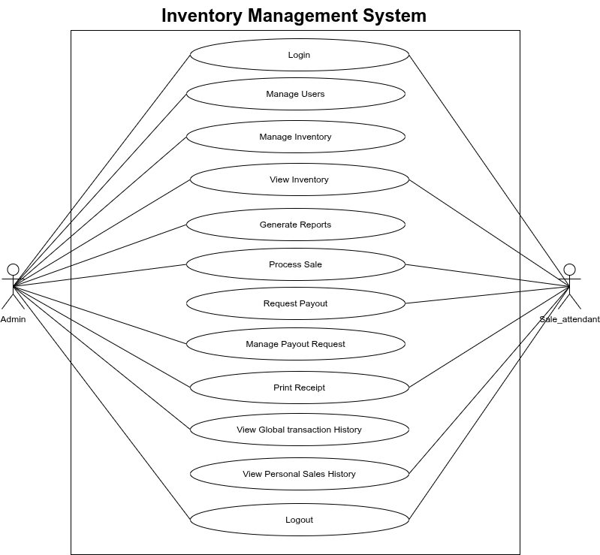
Figure 1 Use Case Diagram of the Galadawa Inventory Management System
Figure 1 presents the unified use case diagram of the proposed Galadawa Inventory management System. The diagram provides a high-level overview of the system and illustrates the interactions between the primary actors, namely the Sale Attendant and administrator.
The Sale Attendant interacts with the system to perform sales, check stock, request payout, check transaction history, update profile, and track sales records. The administrator interacts with the system to manage users, accept or reject payout requests, view transactions from all sale attendants, manage inventory by add/remove product, and generate sales reports.
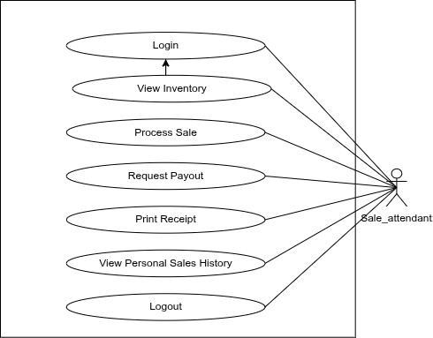
Figure 2 Sale Attendant Use Case Diagram
Figure 2 illustrates the use case diagram for the sale attendant, highlighting the functionalities available to sale attendant within the Galadawa Inventory Management System.

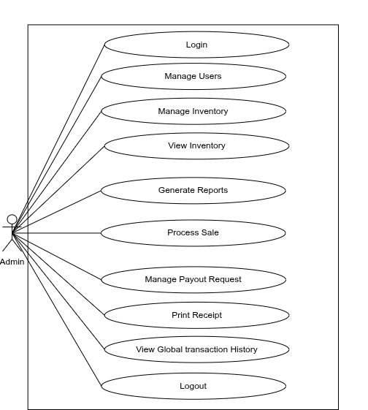
Figure 3 Admin Use Case Diagram
Figure 3 presents the use case diagram for the administrator within the Galadawa Inventory Management System. The diagram illustrates the functionalities available to admin for managing and ensuring the shop activities are running smoothly withing the system.

3.2.5.2 Use Case Descriptions
This section presents detailed descriptions of selected core use cases of the proposed Galadawa Inventory Management System. The chosen use cases represent the most significant system operations for sale attendants and administrators. Other use cases are not described in detail as they follow similar interaction patterns.

Table 1 Process Sale Use Case Description
Use case name: Process Sale |  | ID: UC-01 | Priority: High
Actor: Sale Attendant.
Description: This use case describes how a sales attendant processes a customer transaction, validates stock, and generates a receipt.
Trigger: The attendant launches the process sale page to serve a customer.
Preconditions: The attendant is logged in, and the products being purchased have sufficient stock in the inventory.
Normal course:
1. The attendant searches for a product by name or category.
2. The system displays matching products with current stock levels.
3. The attendant selects the item (specifying variant/color for caps or yardage for textiles).
4. The system validates availability and adds the item to the cart.
5. The attendant confirms the total amount and clicks "Confirm Payment".
6. The system records the sale, deducts stock, and credits the attendant’s commission.
7. The system generates a digital receipt.
Alternative course:
1. The attendant attempts to add a quantity greater than available stock.
2. The system displays an "Insufficient Stock" error.
3. The system blocks the addition until a valid quantity is entered.
Post condition:
1. Product stock is updated (decremented).
2. A new sale record is created.
3. 5% commission is added to the attendant's balance.
Summary
Inputs:  Product selection, Quantity, Payment confirmation | Source:  Sales Attendant. | Output:  Digital Receipt, Updated Stock Level | Destination:  Customer (Receipt), Database (Inventory/Sales)

Table 2 Add New Product Use Case Description
Use case name: Add New Product |  | ID: UC-02 | Priority: High
Actor: Administratior
Description: This use case describes how the administrator adds new inventory items, including setting prices, categories, and uploading product images.
Trigger: The administrator selects "Add Product" from the dashboard menu.
Preconditions: The administrator is logged in and has the necessary product details and images ready.
Normal course:
1. The admin enters product details (Name, Category, Cost Price, Selling Price).
2. The admin uploads product images.
If "Cap": Admin uploads multiple images (system auto-counts quantity).
If "Textile": Admin manually enters yardage.
3. The admin sets the "Low Stock Alert" threshold.
4. The admin clicks "Save Product".
5. The system saves the product and images to the database.
Alternative course:
1. The admin uploads an invalid file type (e.g., PDF instead of Image).
2. The system rejects the file and displays an error message.
3. The product is not saved until valid images are provided.
Post condition:
1. The new product appears in the inventory list.
2. The product becomes available for sale in the POS.
Summary
Inputs:  Product Name, Price, Images, Quantity | Source:  Administrator | Output:  New Inventory Record, Success Message | Destination:  Inventory Database

Table 3 Request Commission Payout Use Case Description
Use case name: Request Commission Payout |  | ID: UC-03 | Priority: Medium
Actor: Sale Attendant
Description: This use case describes how a sales attendant requests a withdrawal of their accumulated sales commission.
Trigger: The attendant clicks on the "Payouts" menu to withdraw earnings.
Preconditions: The attendant has an available commission balance greater than zero.
Normal course:
1. The attendant views their "Available Balance" on the Payouts page.
2. The attendant enters the withdrawal amount and bank account details.
3. The attendant clicks "Request Payout".
4. The system validates that the amount does not exceed the available balance.
5. The system deducts the amount and creates a "Pending" request.
6. The system notifies the administrator.
Alternative course:
1. The attendant requests an amount higher than their balance.
2. The system displays an "Insufficient Funds" error.
3. The request is blocked.
Post condition:
1. The commission balance is debited.
2. A payout request is queued for Admin approval.
Summary
Inputs:  Amount, Account Details | Source:  Sales Attendant | Output:  Pending Payout Request, Updated Balance | Destination:  Administrator Dashboard, Financial Log

The described use cases form the core operational processes of the proposed Inventory management system and lay the foundational basis for the system design and implementation.

3.3 System Design
This section translates the analyzed requirements into a concrete technical blueprint. It defines the architecture, database structure, and process flows necessary to successfully build the new web-based inventory management system.

3.3.1 Description of the Proposed System
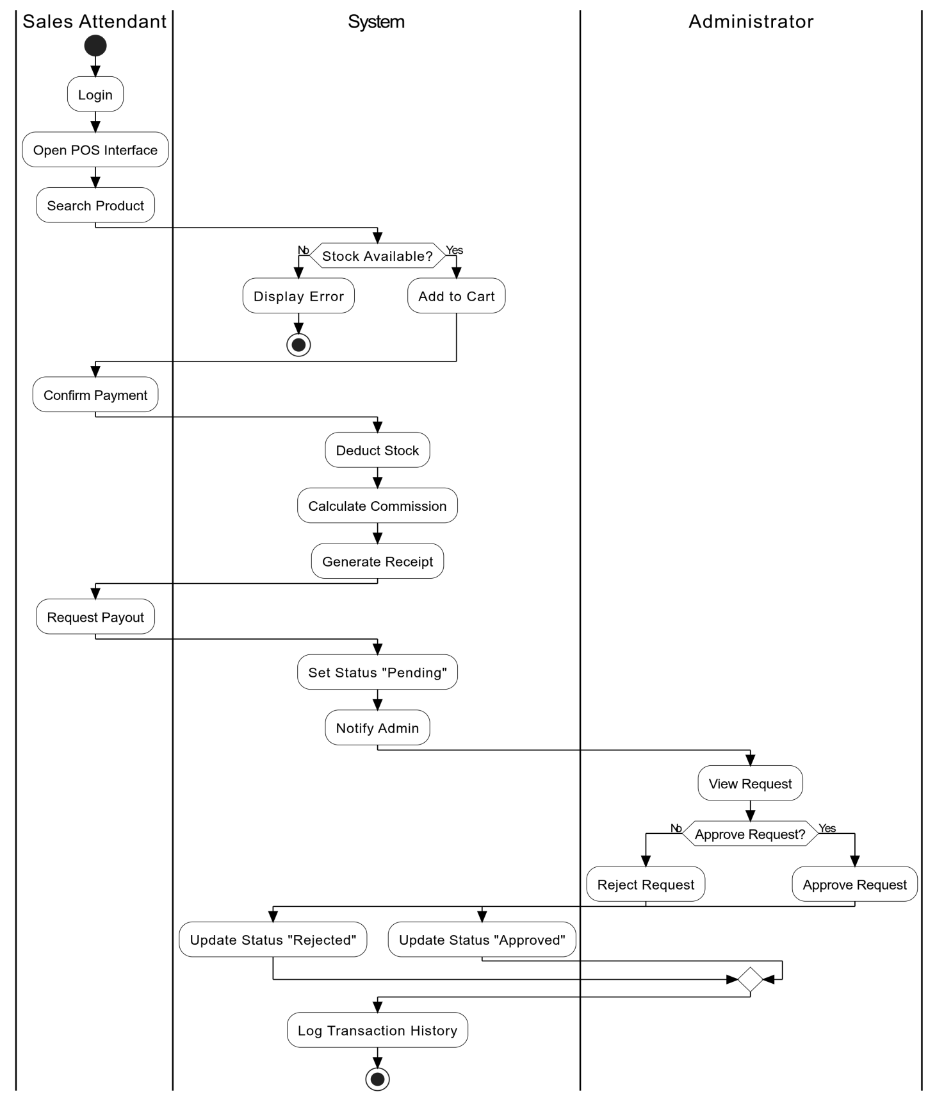
Figure 4 Activity Diagram of the Proposed System
The system that is proposed can be represented as shown in Figure 4 above, where an activity diagram is used to show the workflow of the system, with an emphasis on the interaction between the Sales Attendant, the Administrator, and the System itself. The diagram shows a general view of the workflow of the system without going into details of the code used in the system's implementation.
This starts with a Sales Attendant logging into the system and opening the Point of Sale (POS) window, where they search for a product and select the quantity required. The system then checks a critical condition, where it verifies the availability of the stock from the database, and if the stock is not available, it shows an error message and ends the operation. If the stock is available, then it proceeds with adding the product to the cart and payment processing.
After confirming the payment, the system will automatically carry out three actions: deduct the sold items from the inventory, compute a 5% commission for the attendant, and produce a digital receipt for the customer.
Consequently, the attendant will be able to make a financial transaction by requesting to be paid their earned commission. The status of the request will be updated to "Pending," and the Administrator will be notified.
On the other hand, the proposed system offers Admin privileges to ensure financial integrity. The administrator logs in to verify the pending request and proceed with Approve or Reject. If approve is selected, the status will be "Approved." If reject is selected, the status will be "Rejected." In any case, the transaction history is recorded for an audit trail purpose for the business process.

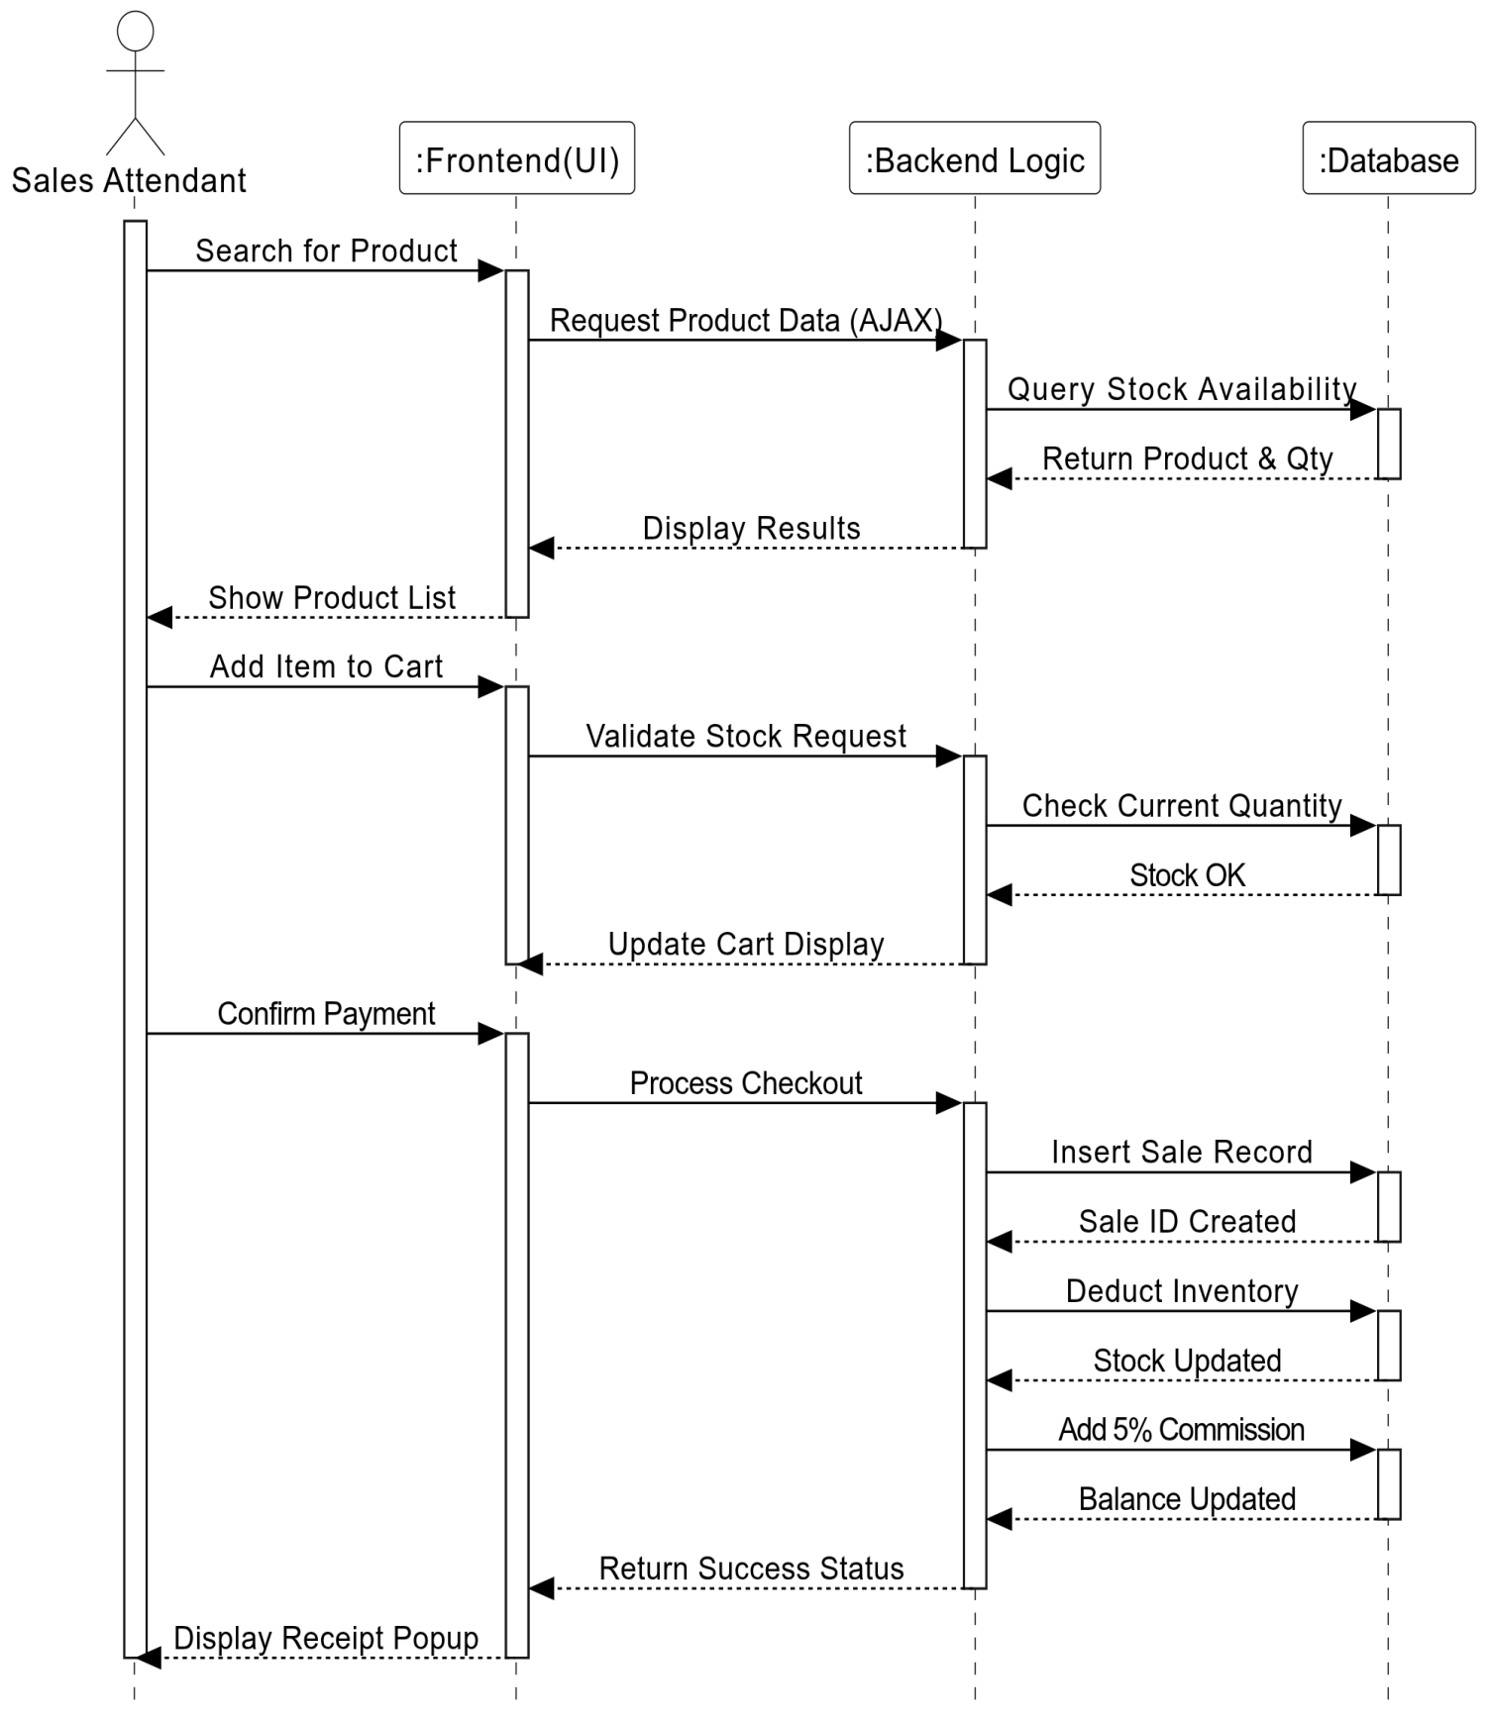
Figure 5 Sequence Diagram of the Proposed System

In addition, the sequence diagram in Figure 5 depicts the detailed steps involved in the process for a Point of Sale (POS) transaction. In the sequence diagram, the Sales Attendant starts the process by looking for a product through the Point of Sale Interface. This interface then sends a request to the Backend Logic, which in turn sends a request to the Database for real-time availability of the product in stock. When the Sales Attendant adds a product to the cart, an on-the-spot validation occurs to ascertain that the quantity of the product required does not exceed the available quantity in stock. After payment, the Backend Logic updates the Database records, where the sale is recorded, the quantity of the product sold is deducted, and the Sales Attendant's account is credited with a 5% commission.

3.3.2 System Development Model
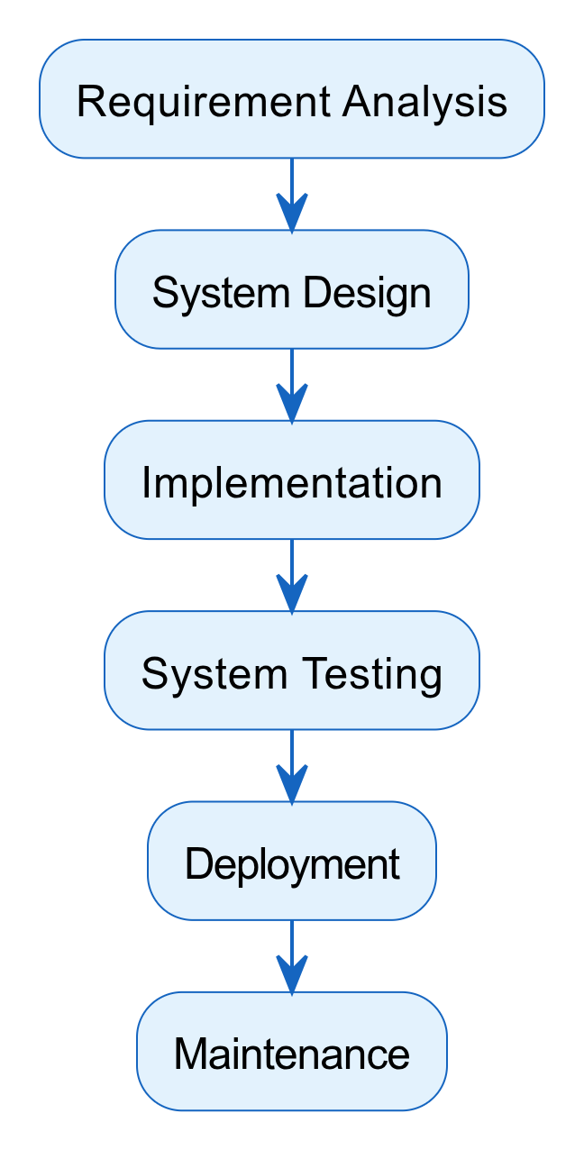
Figure 6 waterfall model
In developing the Galadawa Textiles Inventory Management System, the Waterfall Model was used. This is because, for this project, all requirements were clearly defined and stable from the very beginning, and this model suits such projects best. The Waterfall model ensures that all steps of software development from requirement gathering to testing are fully completed before moving on to the next step, and this ensures that software development is carried out in an organized and disciplined manner.

3.3.3 Architecture Design
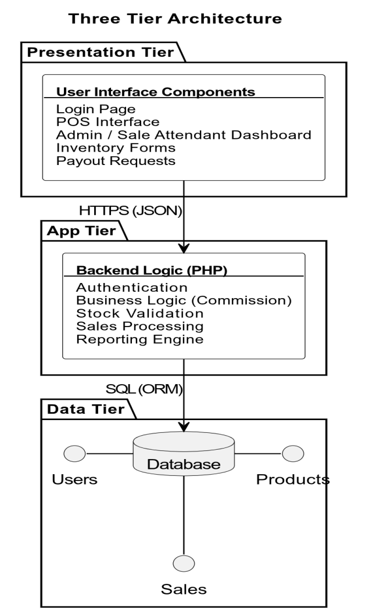
Figure 7 Architecture Design of the Proposed System
Figure 6 shows the architectural design the system will employ, which is a Three Tier Architecture, a design paradigm in which the application is divided into three distinct computer layers: the presentation tier, application tier, and data tier. The presentation tier refers to the user interface through which the user will interact with the application, and in this case, the sales attendants will use the user interface to access the POS interface, and administrators will use the user interface to access the dashboard. On the other hand, the application tier refers to the logic tier in which the data will be processed, and it will act as a bridge or intermediary between the presentation tier and the data tier, in which core application functionalities will take place, such as validation, commission, and sales processing. Lastly, the data tier will refer to the storage and data management functionality, in which product inventory, user profiles, and transaction records will be stored. This setup ensures separation of concerns and allows for scalability, security, maintainability, and flexibility suitable for future expansion and reliability (IBM, n.d.).

3.3.4 Database Design
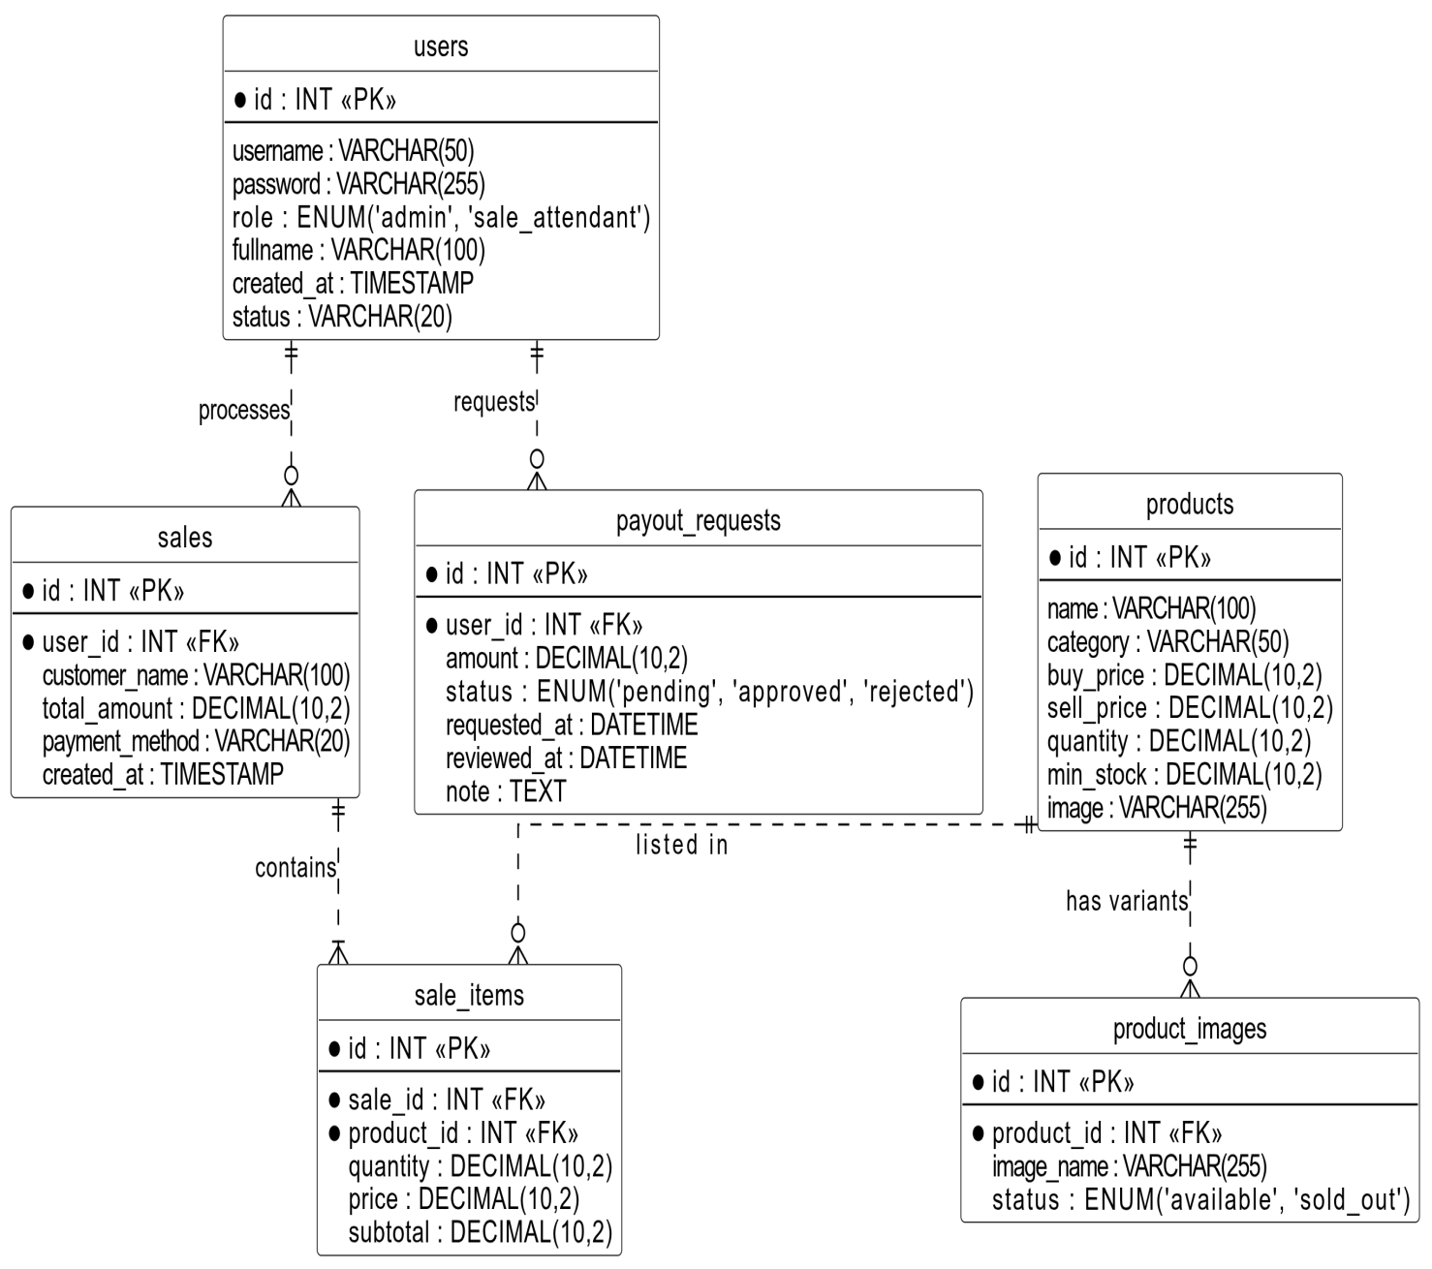
Figure 8 Entity Relationship Diagram of the Proposed System
Entity Relationship Diagram in Figure 7 illustrates the logical structure of the Galadawa inventory management system’s database. It defines the entities, their attributes, and the relationships between Sale attendant, admins and the system. The diagram ensures scalability, data integrity and aligns with the system requirements identified during analysis.

3.3.5 Choice of Programming Language
The Galadawa Inventory Management System uses PHP for server-side scripts and JavaScript for client-side scripts. PHP is a freely available language designed to work specifically in web development and can be directly embedded in HTML code. PHP can manage all the server-side activities of a web page, including user validation, sessions, and databases. On top of all this, PHP provides robust security features to safeguard a website from all sorts of attacks, including SQL injection, cross-site scripting, and cross-site request forgery attacks.
As a bridge between the user interface and the database, PHP has the capability to execute complex scripts like computing a 5 percent commission and checking inventory rules before data is stored in the database. PHP works as a stateless scripting language and works well with the Apache web server, which manages the data transfer from the browser to the server (PHP Manual, n.d.).
On the client-side end, JavaScript is used for scripting with the help of the jQuery library. JavaScript helps update the UI without page reloads by making use of AJAX (Asynchronous JavaScript and XML) technology. This is important especially for the POS page because data transfer needs to happen in real-time to update the inventory. This provides a better browsing experience similar to a desktop application within the browser (MDN Web Docs, n.d.).
The system utilizes the MySQL database management system, which is a powerful and popular open-source relational database management system. The database management system has been chosen for its reliability, efficiency, and usability. The database management system has the capability to perform ACID (Atomicity, Consistency, Isolation, Durability) transactions with the help of its InnoDB engine, which provides data integrity even in the event of a failure. This is particularly useful for a financial-oriented system that handles sales and commission transactions (Oracle, n.d.).

3.4 Summary
This chapter presented the research methodology, which formed the core of this project. The proposed methodology consists of two phases, which are system analysis phase and systems design phase. The analysis part presents the data collection process, analysis of existing system and problems associated with it, and requirements elicitation and definition. The design part showcases the modelling of the proposed system including the flow and interactions within the system, data modelling and architecture design of the system. The next chapter discusses system implementation and testing.

CHAPTER FOUR

SYSTEM IMPLEMENTATION AND TESTING

4.1 Introduction
This chapter describes how the Galadawa Inventory Management System was created and tested for this project. It describes the tools, languages, and development environment that were used, as well as the frameworks and algorithms that power the main features of the Galadawa Inventory Management System. It will also describe how the entire system works, step-by-step, along with screenshots that illustrate the capabilities of the system from the perspectives of sale attendant, and administrator.
It will also discuss the different strategies that were used to test the Galadawa Inventory Management System to ensure that the system works properly, runs well, is secure, and is user-friendly. The process of testing the system covers unit tests, integration tests, system tests, and usability tests to ensure that the system meets the functional and non-functional requirements.

4.2 System Implementation
The development process was carried out in stages. The first stage was to develop the basic authentication and user management aspects, including account creation, role-based access (Administrator and Sales Attendant), and the admin dashboard.
The second stage was to develop the inventory module, which includes adding products (textiles and caps), managing inventory, uploading images for different variants, and setting up low stock alerts.
The third stage was to develop the Point of Sale module, which includes adding items to the cart, completing sales, updating inventory, and calculating a sales commission of 5%.
The final stage was to develop the commission payout request module, logging of transaction history, and improving the user interface.

4.2.1 Implementation Tools
The Galadawa Inventory Management System utilizes different frameworks and libraries of the selected programming languages. The project uses the following tools and technologies:
Frontend Technologies:
- HTML5 and CSS3: are the basis for the markup and styling, which in turn define the user interface. These technologies define the structure of the system.
- JavaScript: The JavaScript library jQuery, being small and packed with features, makes it a delight to work with HTML documents. It makes it easy to manipulate and traverse HTML documents and also provides functionality for AJAX operations. This will enable the POS page to perform transactions and check stock levels in real time.
Backend Technologies:
- PHP (Hypertext Preprocessor): PHP is an open-source server-side scripting language that is used for developing the core business logic of the application. PHP is responsible for secure user authentication, access control, safe database interactions (PDO and prepared statements), and executing complex background calculations for determining 5% sales commissions.
Database Technologies:
- MySQL: is a highly advanced open-source RDBMS for implementing the data tier. It is reliable and efficient in storing and retrieving all the persistent data of the system, including complex relationships between registered users, product inventory, sales transaction history, and commission payout requests.
Development and Server Tools:
- Visual Studio Code: is a code editor that can be used as a development environment for writing, debugging, and maintaining the entire codebase of the application in good shape.
- Apache HTTP Server is used as a local server tool in development and testing, hosting and running the PHP application and integrating the frontend with the backend database.
- GitHub: is a cloud-based platform for storing and sharing code. It used for remote repository hosting of the system’s source code.

4.2.2 Algorithms of Major Functionality
The Galadawa Inventory Management System uses a set of step-by-step logical procedures to process all the user requests and generate the expected results. Below are some of the key functionality algorithms:
- User Authentication Algorithm: It handles verifying login credentials and routing users based on their role.
Input: Username and Password
Output: Access granted to specific dashboard or denied
- Start
- User fills in the login form.
- System validates inputs to prevent empty submissions.
- Verify if the username already exists in the database.
If username does not exist → Display error message.
Else → Continue.
- Verify the entered password against the stored password
If password is incorrect → Display error message.
Else → Continue.
- Check the user's role (admin or sale_attendant) and account status.
- Create a secure session and redirect the user to the appropriate dashboard.
- End

- New Product Registration Algorithm: It handles the addition of new textile and cap inventory by the administrator.
Input: Product details (Name, Category, Buy/Sell Price, Quantity, Min Stock, Image)
Output: Successful inventory addition or error message
- Start
- Admin fills in the new product form and selects an image.
- System validates all required fields and image format.
- Check if the product name already exists in the same category for caps.
If exists → Display error message.
Else → Continue.
- Upload and securely move the product image to the server directory.
- Store the new product details and image path in the database.
- Display success message and clear the form.
- End

- Point of Sales Algorithm: It handles the core transaction logic when a customer purchases items.
Input: Cart items (Product IDs, Quantities), Customer Name, Payment Method
Output: Sale recorded, inventory deducted, and receipt generated
- Start
- Attendant adds products to the POS cart and confirms checkout.
- System calculates the total transaction amount.
- For each item in the cart, check if requested quantity is ≤ available stock.
If requested quantity > available stock → Display "Insufficient Stock" error and halt.
Else → Continue.
- Insert a new record into the sales table with the total amount and attendant ID.
- Insert each cart item into the sale_items table.
- Deduct the purchased quantities from the products table stock levels.
- Generate the transaction receipt.
- End
- Commission Calculation Algorithm: It dynamically calculates and adds the 5% reward to an attendant's profile after a sale.
Input: Total Sale Amount, User ID of the Attendant
Output: Updated commission balance
- Start
- System retrieves the Total Sale Amount immediately after a successful transaction.
- System calculates 5% of the Total Sale Amount (Total Amount * 0.05).
- Retrieve the current commission balance of the Attendant from the users table.
- Add the calculated 5% value to the current commission balance.
- Update the users table to reflect the new, increased commission balance.
- End

- Payout Request Processing Algorithm: It handles the administrator's review of a commission withdrawal request.
Input: Request ID, Note, Admin Decision (Approve/Reject)
Output: Updated request status and adjusted user balance
- Start
- Admin views pending payout requests and selects 'Approve' or 'Reject and add short note'.
- Check Admin Decision.
If 'Reject' → Update request status to 'rejected' and end.
If 'Approve' → Continue.
- Retrieve the requested amount and the attendant's current commission balance.
- Deduct the requested payout amount from the attendant's total commission balance.
- Update the users table with the new balance.
- Update the payout request status to 'approved' and log the approval time.
- Display success message to the admin.
- End
The above steps highlight the system’s main functionalities. The corresponding code for these main features of the system can be found in Appendix.

4.2.3 Description of the developed System
The Galadawa Inventory Management System is a good web-based application designed to streamline sales processes, automate commission tracking, and keep textile and cap inventories in check. It is implemented using PHP and a MySQL database to accurately keep tabs on inventory levels, keep a record of all transactions, and calculate a 5% commission for every sale made to staff. To keep things fast and user-friendly, asynchronous client-side requests using AJAX/jQuery are employed in all core functions of the application. This means that attendants can update their cart quantities in real-time without any delay.
Some of its notable features include an accurate Point of Sale (POS) system that immediately shows changes in inventory levels as soon as a receipt is generated. Another notable feature is a comprehensive financial section where sales attendants can keep an eye on their commission earnings and even make withdrawals.
The system is designed for Administrators and Sales Attendants, each with their own interface for their specific use. The interface components of the system are as follows:

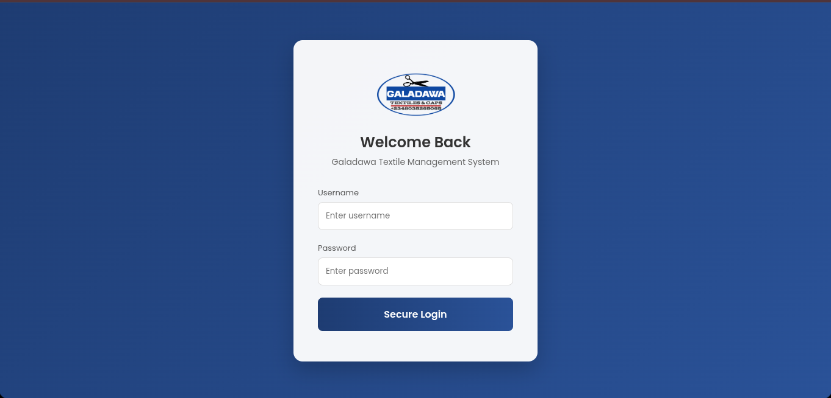
Figure 9 User authentication Module.
The authentication component in Figure 8 indicates the process through which the user gets access to the system in a secure manner. The staff members, whose are registered in the system, enter the username and password as required by the system. The system then directs the user to the required dashboard, either the Administrator dashboard or the sales attendant dashboard, after authenticating the user's details in the database.

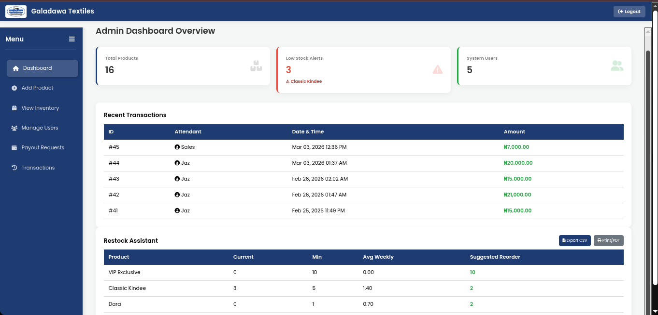
Figure 10 Administrator Dashboard Module.
From this control center, the administrator can register new staff, monitor the sales performance, and keep an eye on the inventory directory.
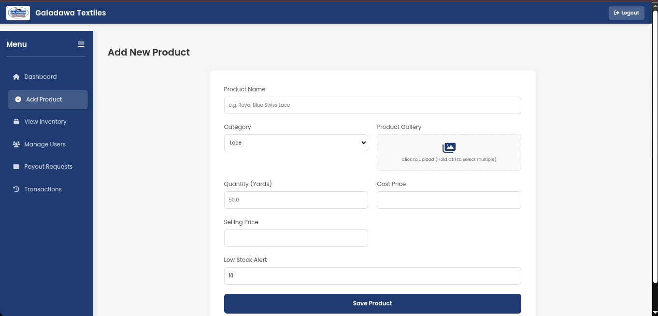
Figure 11 Add Product Page Module.
Figure 10 depict the Inventory Module. the interface is amongs those that function as the central control hub of the system. The features include the ability to add new categories of textiles, upload images of variants for products such as caps, set prices for buying and selling, etc.

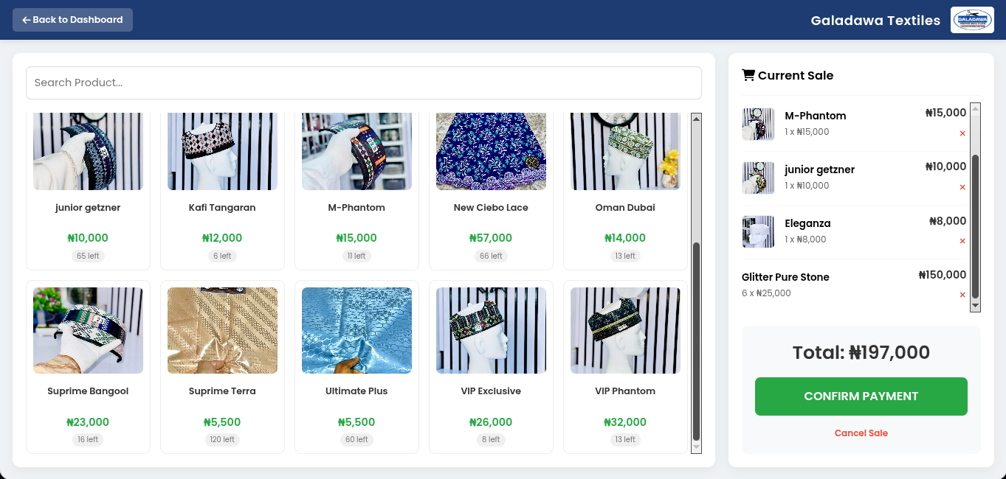
Figure 12 Point of Sale (POS) and Cart Interface Module.
The POS page in Figure 11 above acts as the main workspace for sales attendants, designed to facilitate smooth checkout operations. The sales attendants select products, adjust quantities, and see the subtotal calculated in real time by the system. As soon as the quantity is entered, it checks the database to prevent out-of-stock products and complete the sale before instantly giving a 5% commission to the attendant’s account.
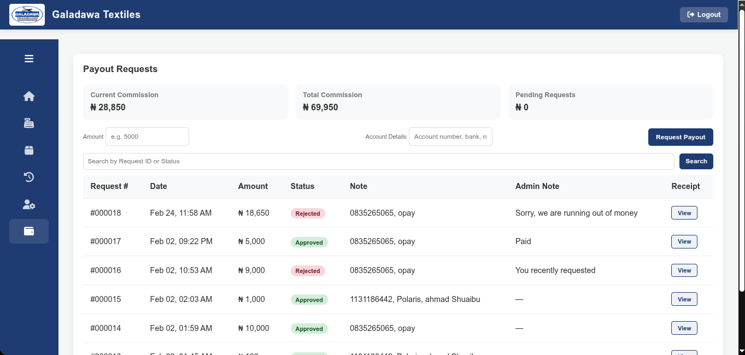
Figure 13 Commission and Payout Request Module.
The financial tracking module in Figure 12 indicates how a commission withdrawal request is processed. Sales attendants can check how much commission they have earned in total and then request a withdrawal. On the administrator side, a table showing all outstanding requests is available, thus giving management a chance to approve or deny a request. Once a decision is made, the financial log is updated accordingly.

4.3 System Testing
System testing of the developed system was conducted to ensure that the system performs as expected. The system testing sought to identify any mistakes, confirm the performance of the system, and ensure that all system modules operate correctly individually and as a whole.

4.3.1 Testing Tools
The tools used for testing the system during development are described in the Table 4.1 below:
Table 4 Testing Tools
S/N | Tool | Description
 | phpMyAdmin | The tool was used to test database schema reviews, data insertion validation, and manual verification of inventory updates and commission calculations in backend testing.
 | Google Chrome DevTools | It was used for debugging frontend errors, monitoring network requests, testing responsiveness and performance inspection.
 | Manual Testing | Manual testing was performed by interacting with the system as a sales attendant and administrator.
 | VSCode Terminal | It was used for debugging requests error and monitoring local server (Apache/PHP) responses and error logs.

4.3.2 Unit Testing
We carried out unit tests on the system to ascertain that each component of the system is working properly. We tested each component of the system individually before combining all the components.

Table 5 Test Case 1: User Aut hentication (Login)
Test ID | Test Description | Input Data | Expected Output | Actual Output | Status
UT-1.1 | Valid Admin Login | Username: admin, Password: correct_password | Grants access and redirects to Admin Dashboard. | System redirected to Admin Dashboard. | Pass
UT-1.2 | Invalid Password | Username: jazie, Password: wrong_password | Denies access and displays "Invalid password" error. | Displayed "Invalid password" error message. | Pass
UT-1.3 | Empty Fields | Username: (blank), Password: (blank) | Form validation triggers, preventing submission. | Form highlighted required fields. | Pass
The table proves that the system's login security and validation protocols are functioning exactly as intended.
Table 6 Test Case 2: New Product Registration
Test ID | Test Description | Input Data | Expected Output | Actual Output | Status
UT-2.1 | Valid Product Entry | Name: Glitter Pure Stone, Category: Atampa,  Qty: 11, Price: 5000 | Product is saved to the database and appears in the inventory list. | Product successfully saved and displayed. | Pass
UT-2.2 | Missing Quantity | Name: Supreme Terra,  Qty: (blank) | System rejects entry and asks for required fields. | System displayed "Quantity is required" error. | Pass
The table demonstrates that the system's product registration module successfully handles valid data entries and properly catches incomplete form submissions!
Table 7 Test Case 3: POS Stock Validation
Test ID | Test Description | Input Data | Expected Output | Actual Output | Status
UT-3.1 | Valid Stock Sale | Product Qty: 10,  Requested Qty: 3 | Item added to cart successfully. | Item added to cart and subtotal calculated. | Pass
UT-3.2 | Over-Stock Request | Product Qty: 5,  Requested Qty: 10 | System blocks the action and shows "Insufficient Stock". | Displayed "Insufficient Stock" alert. | Pass
UT-3.3 | Zero Stock (Sold Out) | Product Qty: 0,  Requested Qty: 1 | System prevents the item from being displayed in the POS. | Item did not show in the POS interface. | Pass

4.3.3 IntegrationTesting
Integration testing was also performed to verify that the different components of the Galadawa Inventory Management System work harmoniously when integrated into one system. This part of the testing ensured that the movement of data occurs as well as the interface of the frontend components with the backend database. The tables below outline the integration test cases performed on the system.
Table 8 Test Case 1: POS and Inventory Module Integration
Test ID | Test Description | Input Data | Expected Output | Actual Output | Status
IT-1.1 | Auto-Deduct Stock | Process a POS transaction for 5 yards of Supreme Terra Shadda. | System completes the sale and automatically deducts 5 yards from the products table's quantity for Supreme Terra Shadda. | Sale completed, stock level updated accurately in the database. | Pass
IT-1.2 | Multi-Item Deduction | Process a sale containing 2 units of Atiku Caps and 10 yards of Glitter atampa. | System correctly identifies both items and deducts the respective quantities from the inventory. | System correctly identifies both items and deducts the respective quantities from the inventory. | Pass
The table highlights a crucial success in the system: the frontend checkout perfectly integrates with the backend database to automatically manage real-time stock levels without manual errors!
Table 9 Test Case 2: POS and User Commission Integration
Test ID | Test Description | Input Data | Expected Output | Actual Output | Status
IT-2.1 | 5% Commission Calculation | Complete a sale totaling ₦10,000 by Attendant jazie. | System calculates 5% (₦500) and adds it to the attendant's commission balance in the users table. | ₦500 was successfully added to the attendant's total commission balance. | Pass
IT-2.2 | Zero-Value Sale Handling | Attempt to process a transaction with a total of ₦0. | System rejects the sale or calculates ₦0 commission, preventing errors in the balance. | System calculated ₦0 commission, balance remained unchanged. | Pass
The table proves that the automated financial backend flawlessly calculates attendant rewards and securely handles irregular inputs!
Table 10 Test Case 3: Payout Request and Admin Approval Integration
Test ID | Test Description | Input Data | Expected Output | Actual Output | Status
IT-3.1 | Admin Approves Payout | Admin clicks 'Approve' on a pending ₦2,000 payout request. | Request status changes to 'approved', and ₦2,000 is subtracted from the attendant's current commission balance. | Status updated to 'approved' and user balance successfully adjusted downward. | Pass
IT-3.2 | Admin Rejects Payout | Admin clicks 'Reject' on a pending payout request. | Request status changes to 'rejected', but the attendant's commission balance remains untouched. | Status updated to 'rejected', user balance was not deducted. | Pass
The table shows that a Sales attendant can submit a pending payout request for his earned commission, which the administrator can then either approve to securely deduct the funds or reject to leave the attendant's balance completely untouched, and it works perfectly.

4.3.4 System Testing
System testing involves testing the whole system at one go. This testing was conducted to ensure that the system is functioning correctly and meets the necessary requirements, both functional and non-functional, of the system. The test was conducted under normal circumstances, ensuring that there are no crashes, database operations are performed correctly, data is correctly retrieved, sessions are correctly managed, and authentication is correctly performed.
- Administrator login
- Staff (Sales Attendant) registration
- Addition of new inventory (textiles and caps)
- Sales Attendant login
- Point of Sale (POS) cart management
- Checkout and transaction processing
- Automatic inventory stock deduction
- 5% sales commission calculation and allocation
- Commission payout request submission by the attendant
- Payout approval and balance deduction by the Administrator.

4.3.5 Usability Testing
Usability testing was conducted to evaluate the usability of the platform and the smoothness of the interface. A small group of users, consisting of 2 administrators and 5 prospective sales attendants, interacted with the system and provided feedback on the following grounds:
- Ease of navigation
- Clarity of instructions
- Responsiveness of the interface
- Simplicity of the system
- Clarity of the sales and commission workflow.
The feedback indicates that the POS terminal is extremely intuitive to use, the admin interface is simple to use, and the overall system requires minimal technical training for new employees to begin processing sales effectively.

4.4 Summary
In this chapter, the reader is taken on a tour of how the Galadawa Inventory Management System was developed, including how it was tested. The reader learns about the various web technologies used, such as PHP, MySQL, and JavaScript, as well as server tools used during the development of the system. Then, the reader learns, step by step, how the system’s key features work, such as how the system authenticates users, how it processes POS transactions, how it calculates commissions, among other key features of the system. The reader also learns about the various ways the system was tested, including how the final product meets the needs identified during system analysis.

CHAPTER FIVE

SUMMARY, CONCLUSION AND RECOMMENDATIONS

5.1 Summary
The major objective of this project was to design and implement an effective and reliable web-based inventory management system that would replace the inefficient and inaccurate traditional methods of keeping records that were being used at Galadawa Textiles. The traditional method of keeping records using paper ledgers was cumbersome and prone to errors and loss of documents. This project, which used the Waterfall Model, ensured that requirements were well defined and executed properly. This project has a well-founded Three-Tier Architecture design for a proposed web-based solution. For the front end, HTML5, CSS3, and JavaScript using jQuery have been used for a dynamic user interface, and asynchronous AJAX has been used for real-time POS functionality. This project used PHP for the back end and a MySQL database for secure user profile, product variant, and transactional history storage. The software has been thoroughly tested to ensure that it meets both functional and non-functional requirements. The resulting system successfully automates key business operations across two main user roles: the Administrator and the Sales Attendant.
- The Administrator module provides comprehensive control over the store's operations. Management can easily add, update, and delete textile products, while keeping real-time track of stock levels to prevent shortages or dead stock. The administrator also manages staff accounts, ensuring secure access to the platform.
- The Sales Attendant module provides a simple Point of Sale (POS) interface. Attendants can quickly search for fabrics, process sales, and provide electronic receipts for customers. At the time of sale, the system will automatically remove the items from the database, eliminating the need for manual stock reconciliation at the end of the day.
- Another great feature of the system is the automated commission tracking. For each sale made, the system will automatically calculate the share of the attendant based on the defined percentage. This eliminates the problem of calculating the share of the sales for the attendant. The staff can simply request the payment of their commission through the system, and the administrator can easily approve the request.

5.2 Conclusion
The Galadawa Textiles Inventory Management System represents a quantum leap in technology for the store, transforming the traditional bookkeeping system into an electronic, streamlined system. The system eliminates the problems associated with the use of paper-based documentation for inventory and sales management. Instantaneous synchronization of the database ensures that the management is aware of the current stock, daily transactions, and the financial status of the business. The owner can thus make informed decisions rather than speculating based on the former system. The system also automates the commission and payment requests, thus creating an environment that is conducive for the employees. The sales attendants are able to monitor their performance and the amount of money they are earning, thus boosting their morale. The administrator has full control over the transactions and the payments made to the employees. The system represents the culmination of an effective, secure, and user-friendly system that eases the daily transactions for the textile business.

5.3 Recommendations
Based on the findings of this study and the successful implementation of the software, the following recommendations are proposed to ensure the system is utilized to its full potential:

5.3.1 Operational Recommendations for the Store
- Management must conduct comprehensive and hands-on training for every staff member in the sales section. Every staff member must be familiar and comfortable using the POS interface, stock verification, and processing payout requests.
- For the smooth operation of the business and the avoidance of errors during checkout, the store must provide the counter with computer systems and a UPS.
- Management must ensure that the store enforces strict password usage for every user. If a staff member leaves the company, the management must suspend the user's account immediately.

5.3.2 Recommendations for Future Enhancement
For future developers and researchers looking to expand upon the foundation laid by this project, the following features should be considered:
- The system can be upgraded to send SMS or Email alerts to the administrator whenever a product goes below a certain critical level of stock, thus alerting them instantly.
- The system can be upgraded to include a mobile app option, allowing the manager to monitor the store’s performance even when they are not physically in the store. The app can also be used by sales staff to check stock availability directly from the screen.
- Looking ahead, future upgrades can include advanced sales analytics tools such as charts and graphs to enable the organization to identify peak sales periods, best-selling fabrics, etc.
.

REFERENCES
A, M. O. (n.d.). Web-Based Intelligent Inventory Management System. In International Journal of Trend in Scientific Research and Development (Vol. 1, Number 4). Retrieved www.ijtsrd.com
Ahmad, S., Miskon, S., Alabdan, R., & Tlili, I. (2020). Towards sustainable textile and apparel industry: Exploring the role of business intelligence systems in the era of industry 4.0. Sustainability (Switzerland), 12(7). https://doi.org/10.3390/su12072632
Ayomide, O., Oladunni Abosede, D., & Kolawole Gabriel, A. (2024). A Review of Existing Inventory Management Systems. In International Journal of Research in Engineering and Science (IJRES) ISSN (Vol. 12). www.ijres.org
Dwiwijaya, K. A. (2024). E-Business and Digital Marketing: Integrating Management Information Systems for Competitive Advantage. Global International Journal of Innovative Research, 2(6), 1056–1067. https://doi.org/10.59613/global.v2i6.175
Fahmi, A., Khan, A., & Abdeljawad, T. (2025). A novel approach to group decision-making using generalized bipolar neutrosophic sets. PLOS ONE, 20(6 June). https://doi.org/10.1371/journal.pone.0317746
Gaborno, J. A. B., Grace, Jill, Ernal, G., Stephanie, M., Gange, R. L., Grace, Jan, Mucho, P., Cariaga, K. G., Ibieza, D. B., Egael, J. J., & Gentapanan, R. G. (n.d.). Micro-Business Owners’ Inventory Management Practices. https://doi.org/10.47772/IJRISS
Gomes, A. C., De Lima Junior, F. B., Soliani, R. D., Oliveira, P. R. de S., De Oliveira, D. A., Siqueira, R. M., Nora, L. A. R. da S., & De Macêdo, J. J. S. (2023). Logistics management in e-commerce: challenges and opportunities. Revista de Gestão e Secretariado (Management and Administrative Professional Review), 14(5), 7252–7272. https://doi.org/10.7769/gesec.v14i5.2119
Heizer, J. , Render, B. , & Munson, C. C. (2017). Operations management: sustainability and supply chain management. Journal of Purchasing and Supply Management, 19(4).
Muhammad, M. (2018). THE END OF HISTORY: THE ROLE OF IMMIGRANTS IN KANO TEXTILE INDUSTRY. Malaysian Journal of International Relations, 6, 67–83.
Obadire, A. M., Lesego, B., Naledi, B. &, Moyo, T., Lesego Boitshoko, B., & Naledi, &. (2022). Analysis of the Impact of Inventory Management Practices on the Effectiveness of Retail Stores in South Africa. https://orcid.org/0000-0003-
Pooja A R, Narmada R, & Kiran Kumar M N. (2024). Inventory Management System. International Journal of Advanced Research in Science, Communication and Technology, 296–300. https://doi.org/10.48175/ijarsct-19047
Shazna, S. F. (2021). AN EFFECTIVE PROCUREMENT AND INVENTORY MANAGEMENT SYSTEM FOR ABC TEXTILE SHOP. In International Journal of Engineering Applied Sciences and Technology (Vol. 5). http://www.ijeast.com
Siregar, R., & Sudarmanto, E. (2023). Beyond Traditional Boundaries: Embracing Digital Transformation for Enhanced Management Efficiency at Micro and Small Business Enterprises. In West Science Interdisciplinary Studies (Vol. 01, Number 06).
Swastyastu, C. A., Shanty, R. N. T., Sari, R. P., & Wikanningrum, A. (2024). Agile Implementation for Inventory (Case study: Business Unit of Private University). Journal of Information Technology and Cyber Security, 2(1), 1–14. https://doi.org/10.30996/jitcs.10060
Tong, C. (2025). An Efficient Intelligent Semi-Automated Warehouse Inventory Stocktaking System. http://arxiv.org/abs/2309.12365

APPENDIX
